INITIAL HEALTHCONNECT ANALYSIS REPORT

1. Data Preparation Summary
The dataset consists of 5,000 appointment records across 18 fields, covering 1,696 unique patients with appointments booked between November 2024 and June 2026. Before analysis, the following checks and preparation steps were carried out:

Data Quality Checks
- No duplicate appointment IDs or duplicate rows were found across the 5,000 records.
- Date logic was fully consistent:
- No logical inconsistencies were found in patient history fields

Missing Data
- reminder_channel was blank in 27.3% of rows. This is structural, not missing, since it aligns exactly with reminder_sent = "No".
- distance_to_clinic_km had genuine gaps in 1.8% of rows; waiting_time_minutes in 1.2%. Both were flagged rather than imputed to avoid introducing bias into distance- and time-based breakdowns.

Feature Engineering
- A per-patient no-show count was derived from previous_no_shows to support the repeat-offender concentration KPI.

Data Integrity Note
waiting_time_minutes is populated even for No-Show appointments, with an average (~24 minutes) nearly identical across Attended, No-Show, and Cancelled outcomes. This is inconsistent with how a genuine "patient wait time" should behave for a patient who never arrived, and is flagged for clarification with the data source rather than used as a reliable analytical variable.

2. Exploratory Data Analysis
Here are some of the visuals from exploratory analysis examined how appointment outcome (Attended / No-Show / Cancelled) varies across each available field. The overall outcome split is shown below, followed by the variables found to have the strongest relationship with no-shows.
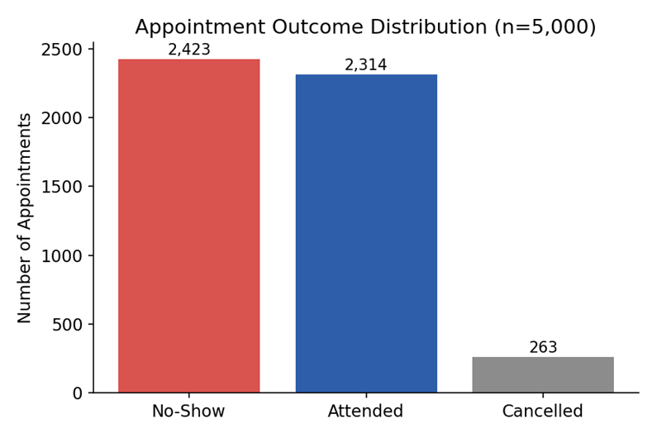
- Previous no-shows: no-show rate rises from ~44% (0 prior no-shows) to 100% (5+ prior no-shows) — the strongest single signal in the dataset.
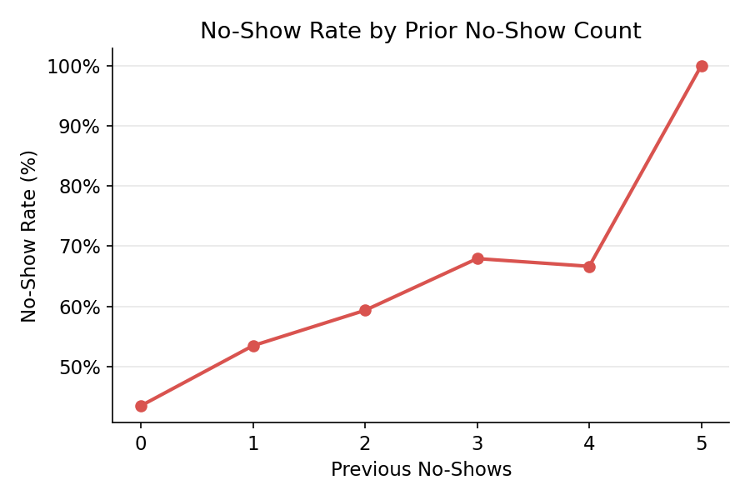

3. KPI Calculations

No-Show Rate
The proportion of scheduled appointments where the patient did not attend.
It's the headline measure of lost clinical capacity. Every no-show is a slot that could have gone to another patient, wasted staff time, and lost revenue. It's the top-line number any intervention is ultimately trying to move.
$$No Show Rate=\frac{No Show Appointments}{Total Appointments}$$
From the data, it comes to about 48.46%. Nearly half of all scheduled appointments never happen. This is a structural capacity problem large enough to justify dedicated intervention.

Reminder Effectiveness (Lift)
The difference in no-show rate between appointments where a reminder was sent versus not sent.
Lift=No-Show Rate (No Reminder)−No-Show Rate (Reminder Sent)
Reminders reduce a no show rate by about 8%. This supports continuing and possibly expanding reminder outreach, but the no-show rate stays high (47.4%) even with a reminder sent, meaning reminders alone are necessary but not sufficient, and should be paired with other interventions.

Repeat-Offender Concentration
The share of all no-show appointments attributable to patients with 2 or more total no-shows.
$$Repeat Offender Concentration=\frac{Patients with 2+no shows}{Total No Shows Overall}$$
No-shows are heavily concentrated. 40% of patients account for nearly three-quarters of all no-shows. This means HealthConnect doesn't need to change how every patient is handled; a focused program aimed at repeat no-show patients (extra outreach, alternative scheduling, deposit requirements) could meaningfully reduce the overall no-show rate far more efficiently than a clinic-wide policy change.

4. Dashboard

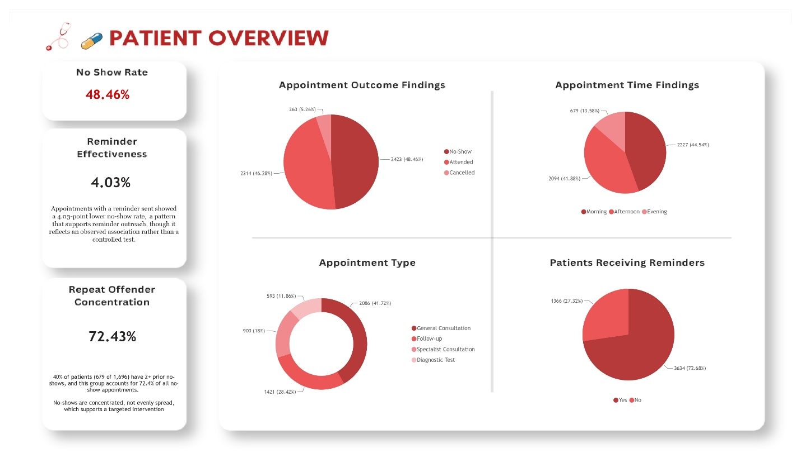
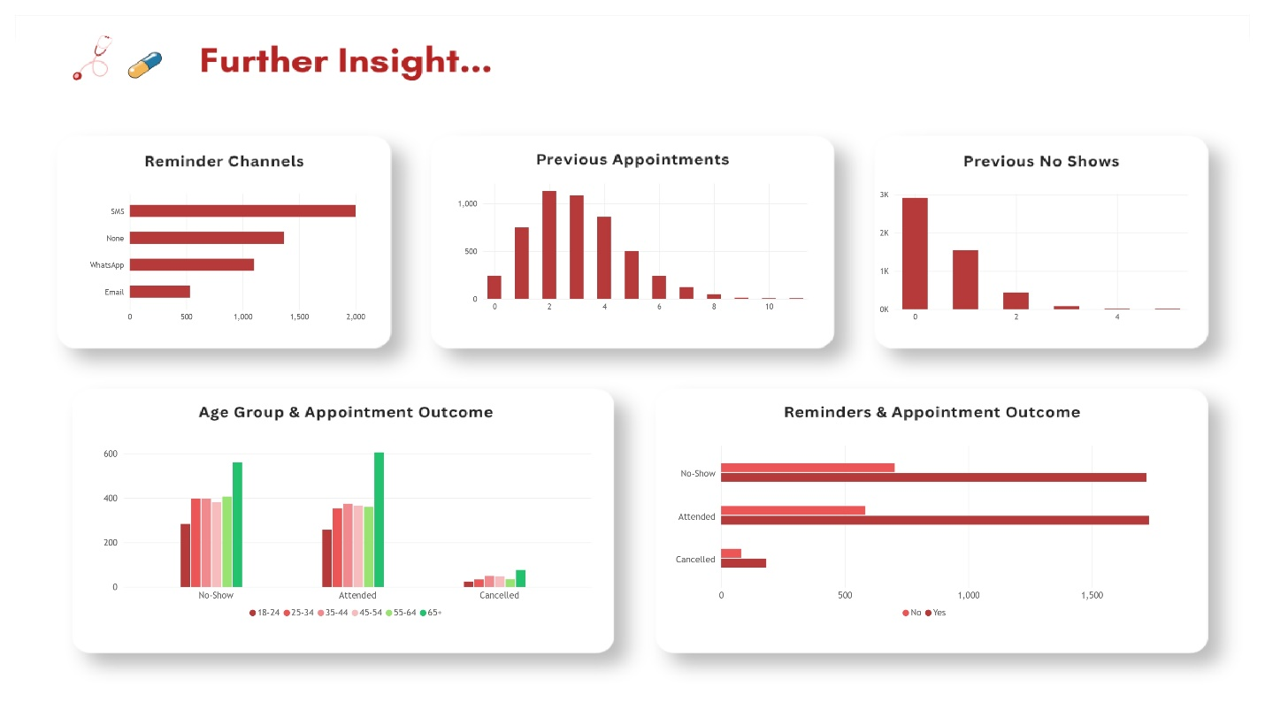

5. Key Findings
- No-Show (48.46%), Attended (46.28%), and Cancelled (5.26%) are nearly evenly split between attendance and non-attendance. No-Show + Cancelled combined accounts for 53.7% of all scheduled appointments, meaning more appointments are lost than kept.
- Reminder effectiveness sits at just 4.03 percentage points. Appointments with a reminder still no-show at a high rate, meaning reminders are reaching the majority of patients but aren't moving the needle much on their own.
- Since SMS is the primary channel and channel-level no-show rates were found to be similar earlier, there isn't strong evidence yet that switching channels alone would meaningfully change outcomes.
- 72.43% of no-shows come from patients with 2+ prior no-shows. It confirms no-show loss is concentrated, not distributed evenly across the patient base, and supports a targeted rather than blanket intervention.

6. Business Recommendations
- Prioritise a targeted intervention for repeat no-show patients (2+ prior no-shows) rather than a blanket, clinic-wide change
- Introduce additional confirmation steps (phone call, text, deposit requirement, rescheduling etc) for patients with a high prior no-show count at the point of booking.
- Test how reminders are sent (e.g., a second reminder closer to appointment time, a two-way confirm/cancel reply) rather than simply increasing reach, since reach is already high but impact is capped.
- Test to see if Email drives meaningfully different outcomes, or shifting those patients with Email set as their reminder channel to SMS/WhatsApp if Email isn't adding value
- Track the three core KPIs (No-Show Rate, Reminder Lift, Repeat-Offender Concentration) on an ongoing dashboard to monitor whether interventions are working.

7. Limitations
- This is a snapshot of current totals, not a trend view — it does not yet show whether metrics are improving, worsening, or stable over time, so it cannot confirm whether any intervention is working.
- The reminder-effectiveness figure is an observed pattern in the data, not a confirmed causal effect.

